MOLECULAR ORBITAL THEORY

Molecular-Orbital Theory (MOT)

It was proposed by Hund and Mulliken in 1932. According to this theory, all atomic orbitals of the atoms participating in molecule formation get disturbed when the concerned nuclei approach nearer. They all get mixed up to give rise to an equivalent number of new orbitals that belong to the molecule now. These are called the molecular orbitals.

It explains the formation of a covalent bond in a better way.

Main Features

- A molecule is quite different from its constituent atoms,
- Atomic orbitals (AO’s) of individual atoms combine to form molecular orbitals (MO’s) and these MO’s are filled up in the same way as AO’s are formed. (Pauli’s exclusion principle, Aufbau principle & Hund’s rule)
- The MO’s have definite energy levels.
- The shapes of MO’s formed depend upon the shape of combining atomic orbitals.

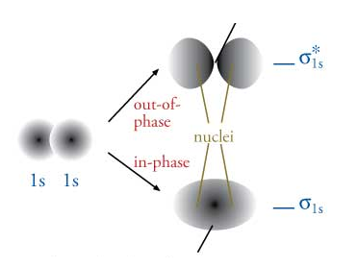
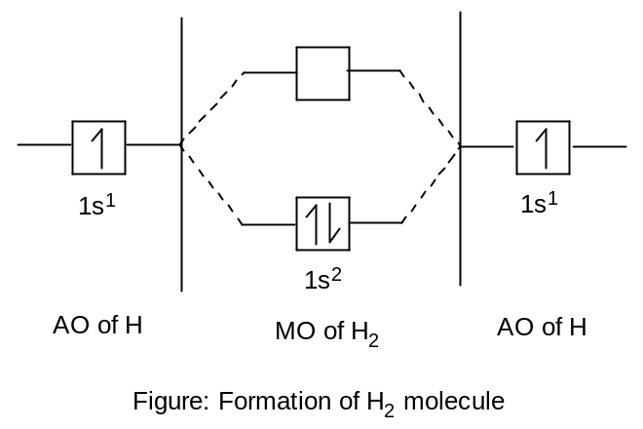

Bond Order (BO)

The number of bonds in a molecule is one-half of the difference of the number of electrons in the bonding molecular orbitals (BMO’s) and the number of electrons in the anti-bonding molecular orbitals (ABMO’s).

Mathematically we can write,

B.O. = = 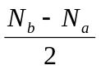

Information given by MOT

Applying the above formula the following information can be determined.

- Stability of the molecule or ion
  - A molecule is stable if 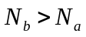; for example- H₂

The hydrogen molecule contains two bonding electrons in the lowest energy bonding orbitals labelled as σ(1s). This can be written as

H (1s¹) + H (1s¹) = H₂ (σ1s)²

The upper anti-bonding orbital labeled as σ*(1s) is empty.
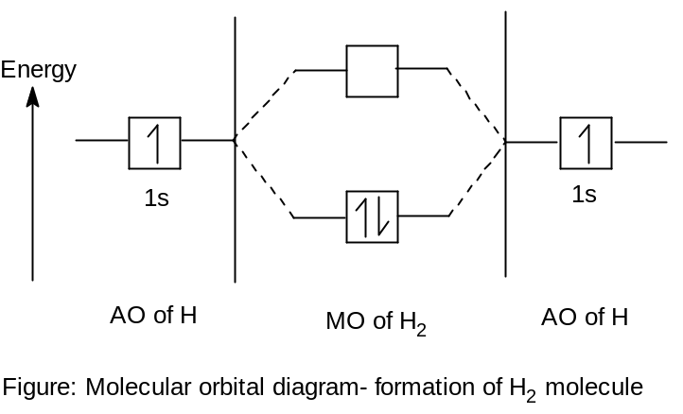
σ*(1s)
σ(1s)

Bond order in H₂ molecule is 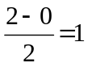. Thus two atoms of hydrogen are bonded through only one bond in the molecule and hence stable.

  - A molecule is unstable if 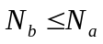; for example- He₂

The number of electrons in the bonding σ(1s) and anti-bonding σ*(1s) are equal and hence the attraction and the repulsion between the elerctrons of the two atoms of He₂ are equal.

Bond order in He₂ molecule is 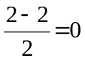.
Therefore, helium molecule is not formed i.e. unstable.

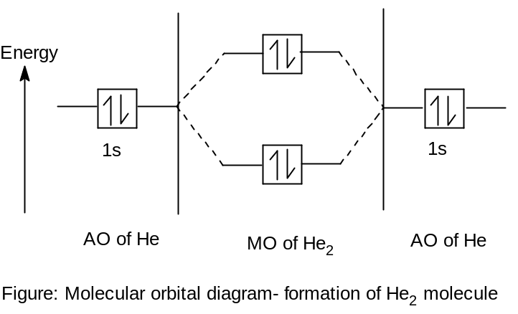
σ*(1s)
σ(1s)

- Bond dissociation energy
Greater the bond order greater is the bond dissociation energy.

- Bond length
Bond order (BO) is inversely proportional to the bond length (BL). i.e. 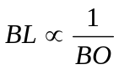
Higher the BO, smaller the BL

- Magnetic properties

  - If unpaired electron present in MO’s, it is paramagnetic.Examples: O₂, NO CN, etc.
Greater the number of unpaired electrons, the more will be its paramagnetic character. The elements having this property are known as ferromagnetic (strong attraction by magnetic field). Examples: Fe, Co, Ni etc.

  - If there is no unpaired electron in MO’s, it will diamagnetic in nature. Examples: N₂, CO etc.

Molecular orbital diagram: Homonuclear Molecules

- Nitrogen, N₂

Electronic configuration of N atom: N(7)- 1s² 2s² 2p_{x}¹2p_{y}¹2p_{z}¹
Number of valence electrons for one atom of N is 5.
Total number of valence electrons for two atoms of N is 10.

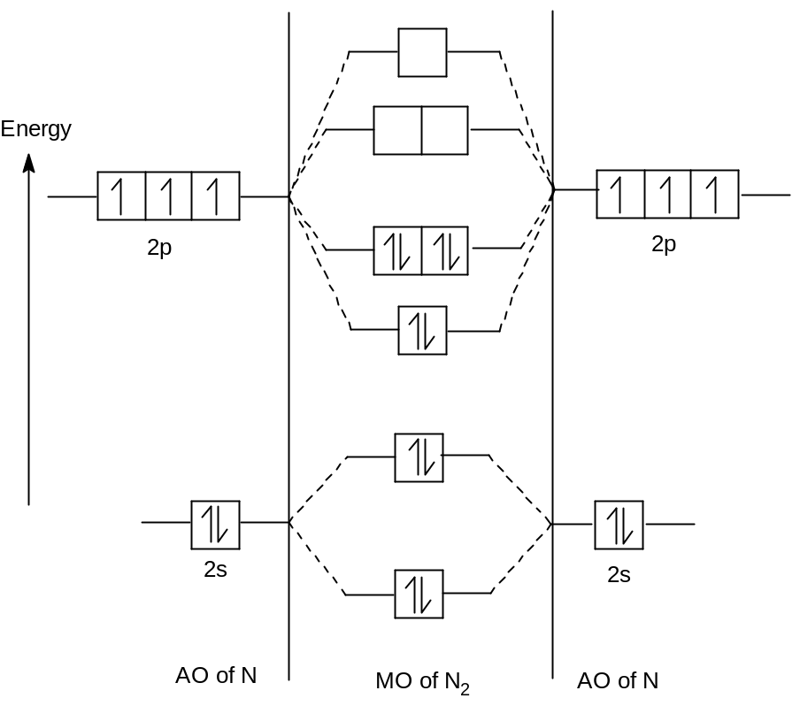
σ(2s)
σ*(2s)
σ(2p_{z})
σ*(2p_{z})
π(2p_{y}) π(2p_{x})
π*(2p_{y}) π*(2p_{x})

(a) Bond order: 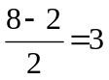; three covalent bond exist and hence stable,
- Magnetic properties: diamagnetic; since there is no unpaired electron.

- Electronic configuration:

KK σ(2s)² σ*(2s)² σ(2p_{z})² π(2p_{y})² π(2p_{x})²

- Oxygen, O₂

Electronic configuration of O atom: O(8)- 1s² 2s² 2p_{x}²2p_{y}¹2p_{z}¹
Number of valence electrons for one atom of O is 6.
Total number of valence electrons for two atoms of O is 12.
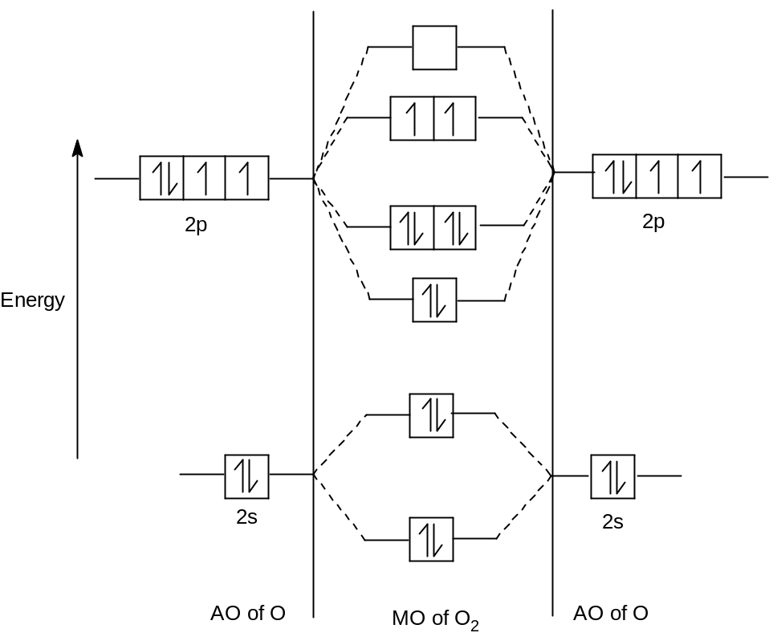
σ*(2p_{z})
σ(2s)
σ*(2s)
σ(2p_{z})
π(2p_{y}) π(2p_{x})
π*(2p_{y}) π*(2p_{x})

(a) Bond order: 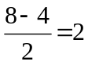; two covalent bond exist and hence stable,
- Magnetic properties: paramagnetic; since there is two unpaired electrons.

- Electronic configuration:

KK σ(2s)² σ*(2s)² σ(2p_{z})² π(2p_{y})² π(2p_{x})² π*(2p_{y})¹ π*(2p_{x})¹

- Neon, Ne₂

Electronic configuration of Ne atom: Ne(10)- 1s² 2s² 2p_{x}²2p_{y}²2p_{z}²
Number of valence electrons for one atom of Ne is 8.
Total number of valence electrons for two atoms of Ne is 16.

(a) Bond order: 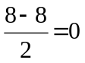; no bond is formed and hence unstable or molecule does not exist,
(b) Magnetic properties: diamagnetic; since there is no unpaired electron in MO’s.
(c) Electronic configuration:
Ne(16) = KK σ(2s)² σ*(2s)² σ(2p_{z})² π(2p_{y})² π(2p_{x})² π*(2p_{y})² π*(2p_{x})² σ*(2p_{z})²

Molecular orbital diagram: Heteronuclear Molecules

- Nitric oxide, NO

Electronic configuration of N atom: N(7)- 1s² 2s² 2p_{x}¹2p_{y}¹2p_{z}¹ (5 valence electrons)
Electronic configuration of O atom: O(8)- 1s² 2s² 2p_{x}²2p_{y}¹2p_{z}¹ (6 valence electrons)

Total number of valence electrons for NO is 11.

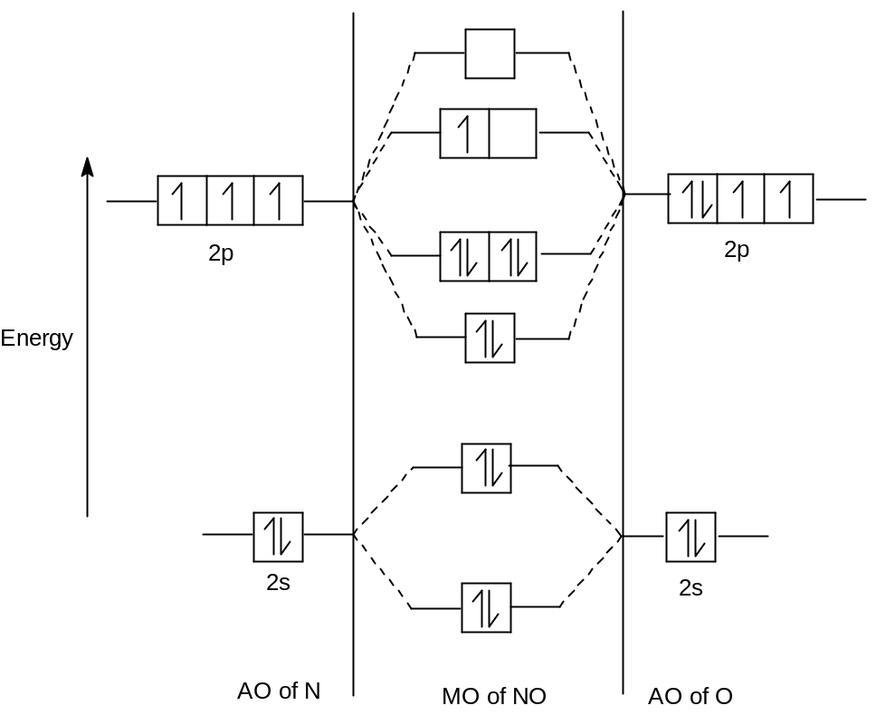
σ*(2p_{z})
σ(2s)
σ*(2s)
σ(2p_{z})
π(2p_{y}) π(2p_{x})
π*(2p_{y}) π*(2p_{x})

(a) Bond order: 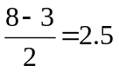;
(b) Magnetic properties: paramagnetic; since there is unpaired electron in MO’s.
(c) Electronic configuration: NO(11) = KK σ(2s)² σ*(2s)² σ(2p_{z})² π(2p_{y})² π(2p_{x})² π*(2p_{y})¹
- Carbon monoxide, CO

Electronic configuration of C atom: C(6)- 1s² 2s² 2p_{x}¹2p_{y}¹2p_{z}⁰ (4 valence electrons)
Electronic configuration of O atom: O(8)- 1s² 2s² 2p_{x}²2p_{y}¹2p_{z}¹ (6 valence electrons)

Total number of valence electrons for CO is 10.

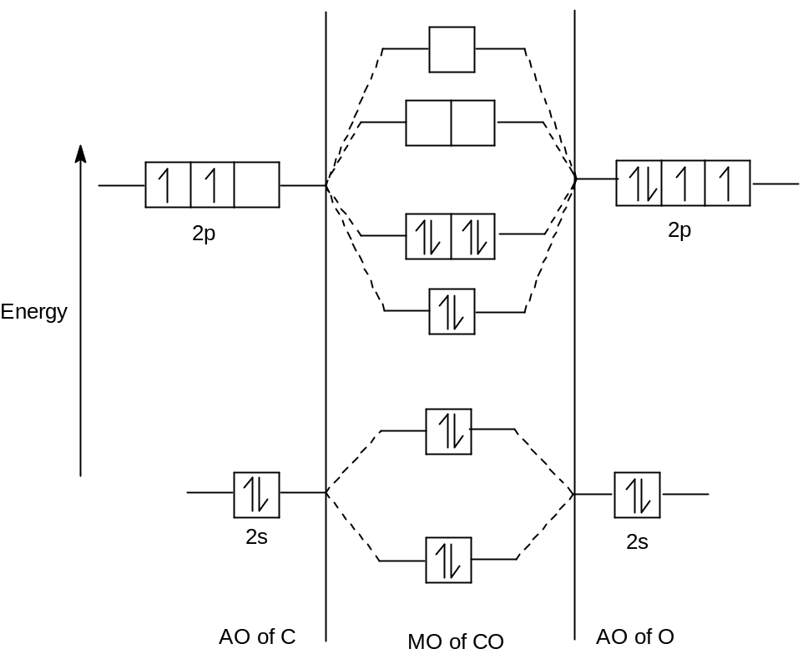
σ*(2p_{z})
σ(2s)
σ*(2s)
σ(2p_{z})
π(2p_{y}) π(2p_{x})
π*(2p_{y}) π*(2p_{x})

(a) Bond order: ;
(b) Magnetic properties: diamagnetic; since there is no unpaired electron in MO’s.

(c) Electronic configuration: CO(10) = KK σ(2s)² σ*(2s)² σ(2p_{z})² π(2p_{y})² π(2p_{x})²

- Cyanide, CN
(Try yourself)

